Thank you for purchasing White Oak Audio Design’s Phase Linear PL400 Upgrade LED Light Board. White Oak Audio Design products are meticulously engineered and tested to ensure a direct drop in fit with your amplifier.
The assembled and installed light board assembly will convert your PL400 Amplifier meter illumination to long life LEDs replacing the incandescent bulbs that burn out frequently and for which replacements are expensive and hard to find. In addition to longer life, the overall power consumption will be reduced as well as heat generated inside the enclosure. Your amplifier will take on that nice blue look that Marantz was famous for (or white if you choose the White LEDs).

Figure 1 below shows how your finished project will look (white illumination if you choose the White LEDs).
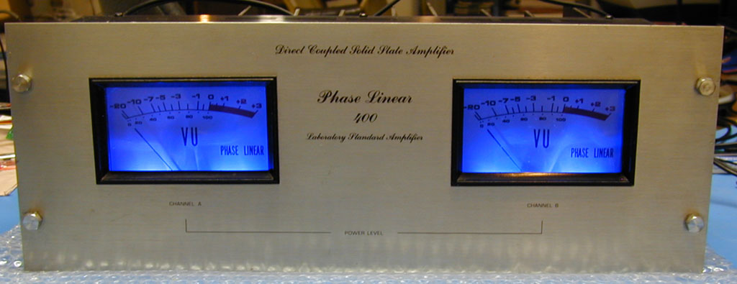
Figure 1 Finished PL400 amplifier project
Assembling the light board printed circuit assembly.
Have a printed copy of these instructions with you prior to performing this assembly procedure.
Skills required:
While assembly of this circuit board is not a difficult procedure, the assembler should be familiar and comfortable with working on electronic equipment and using a soldering station and associated tools. Ensure good control of soldering iron temperature, not exceeding 600 degrees F, so the LED Light Board is not ruined by excessive heat. If you are not familiar with working on electronic equipment or do not possess the proper equipment, it is recommended that you have this assembly performed by a service technician that can perform the LED Light Board assembly and installation for you. It will take several hours to perform the assembly and installation of the light board following these step by step instructions.
Tools required:
- Temperature controlled soldering station or iron – set to 600 degrees F
- 63/37 (preferred) or 60/40 rosin core solder - .031 diameter or smaller
- Good quality Needle nose pliers
- Good quality Diagonal wire cutters
- Axial lead former or bender

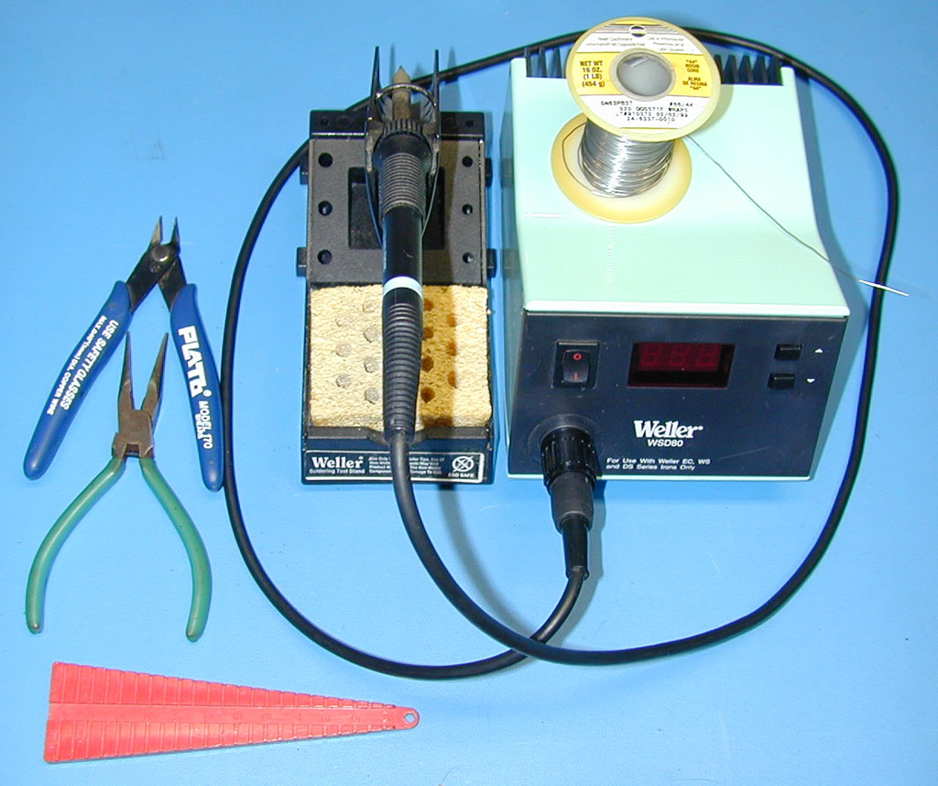
Figure 2: Tools Required

Optional Tools:
- A panavise with board holder is handy for assembling this project but is not required.
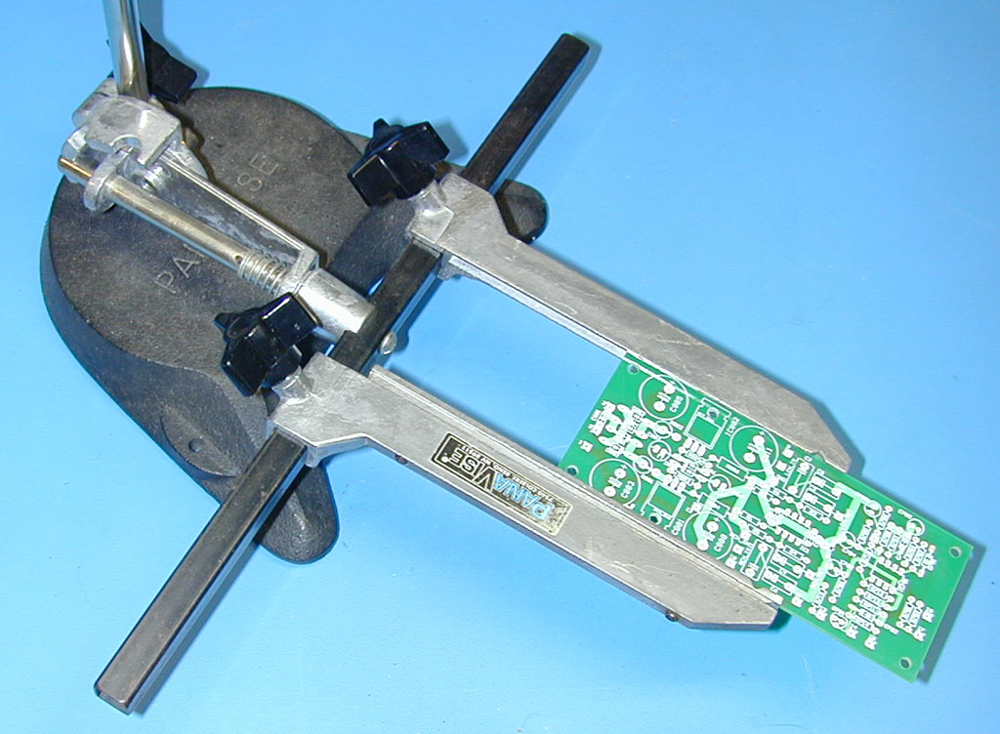
Figure 3: Optional Tools

Table 1
PL400 LED Board (PL18A) Parts List
Item | Qty | Mouser Electronics Part Number | Description | Ref. | Mouser Price Ea. | Ext. Price
1 | 2 | 647-UFW1A332MHD | Capacitor, Electrolytic 3300 uF, 20%, 10V, Nichicon | C1-2 | $0.63 | $1.26
2 | 8 | 593-VAOL-5701SBY4 | LED, X-Brite, Blue, Water Clear, T1-3/4, 100 degrees, 1000 mcd, VCC (alternate part # for LEDs, select one, not all) | LED1-8 | $0.30 | $2.40*
2a | 8 | 593-VAOL-3LSBY4 | LED, X-Brite, Blue, Water Clear, T1, 60 degrees, 1200 MCD, VCC (alternate part # for LEDs, select one, not all) | LED1-8 | $0.29 | $2.32
2b | 8 | 593-VAOL-5701WY4 | LED, X-Brite, White, Water Clear, T1-3/4, 100 degrees, 1800 mcd, VCC (alternate part # for LEDs, select one, not all) | LED1-8 | $0.37 | $2.96
2c | 8 | 593-VAOL-3MWY4 | LED, X-Brite, White, Water Clear, T1, 60 degrees, 2500 MCD, VCC (alternate part # for LEDs, select one, not all) | LED1-8 | $0.36 | $2.88
3 | 8 | 660-MF1/4DC1500F | Resistor, 150 ohm, 1%, 1/4W, Metal Film, KOA Speer | R1-8 | $0.06 | $0.48
4 | 2 | 273-13K-RC | Resistor, 13.0K, 1%, 1/2W, Metal Film, Xicon | R9-10 | $0.14 | $0.28
5 | 1 | 583-RS101 (or 583-RS102) | Bridge Rectifier, 1A, 50V (or 100V), Rectron | B1 | $0.43 | $0.43
6 | 2 | 512-1N914TR | Diode, small signal, 100V, Fairchild | D9-10 | $0.03 | $0.06
 |  |  | Mouser Total |  |  | $4.91*
7 | 1 | WOAD PL18A PCB | Blank PCB, White Oak Audio Design PL400 Light Board
8 | 4 | 6-32 Hex Nuts | Supplied with the light board kit
9 | 3 | Nylon Ty-Rap | Supplied with the light board kit
Order the parts above for the board assembly from Mouser Electronics. Pricing and/or part numbers of items above may have changed since the last revision of this document.
*Bill of Material total based on this LED selection.
Assemble the silkscreen side of the board first (the silkscreen side of the board is the side shown in Figure 4): 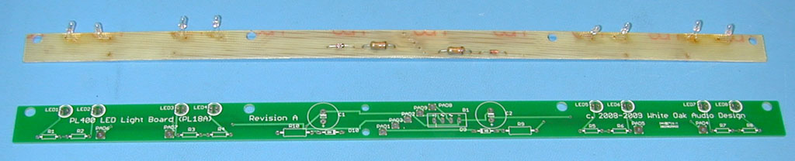
Figure 4 Blank PL18A Light PCB
- Bend the leads of each of the eight 150 ohm resistors on 0.4 inch (10mm) centers as shown in the photo. Carefully install each resistor into the locations marked R1 through R8 as shown in the photo, matching the imprint on the PC board silkscreen. Resistors are not polarized so it does not matter which way you orient them. Carefully solder each resistor to the board. After soldering, clip the excess lead length leaving about 1/16” protruding from the PC board surface.
- Bend the leads of each of the two 1N914 diodes on 0.4 inch (10mm) centers as shown in the photo. Carefully install each diode into the locations marked D9 through D10 as shown in the photo, matching the imprint on the PC board silkscreen. Diodes are polarized so it does matter which way you orient them. Carefully solder each resistor to the board. After soldering, clip the excess lead length leaving about 1/16” protruding from the PC board surface.
- Bend the leads of each of the two 13.0K ohm resistors on 0.6 inch (15mm) centers as shown in the photo. Carefully install each resistor into the locations marked R9 through R10 as shown in the photo, matching the imprint on the PC board silkscreen. Resistors are not polarized so it does not matter which way you orient them. Carefully solder each resistor to the board. After soldering, clip the excess lead length leaving about 1/16” protruding from the PC board surface.
- Install bridge rectifier B1 into the 4 holes in the center of the board, observing the polarity of the bridge rectifier and the silkscreen legend. Make sure you install the bridge rectifier with the correct polarity or the light board will not work and you may damage the LED board components or your amplifier. Carefully solder each of the four bridge leads to the board. After soldering, clip the excess lead length leaving about 1/16” protruding from the PC board surface.
- Install filter capacitors C1 and C2 into the two hole patterns to the right and left of the bridge rectifier observing the polarity of the capacitors and the silkscreen legend. Make sure you install these capacitors with the correct polarity or the light board will not work and you may damage the LED board components or your amplifier. Carefully solder each of the four capacitor leads to the board. After soldering, clip the excess lead length leaving about 1/16” protruding from the PC board surface.
- This side of the board should look like Figure 5 when this step is complete. This completes the assembly of all components that are placed on this side of the PCB. The balance of assembly is from the other side of the PCB.
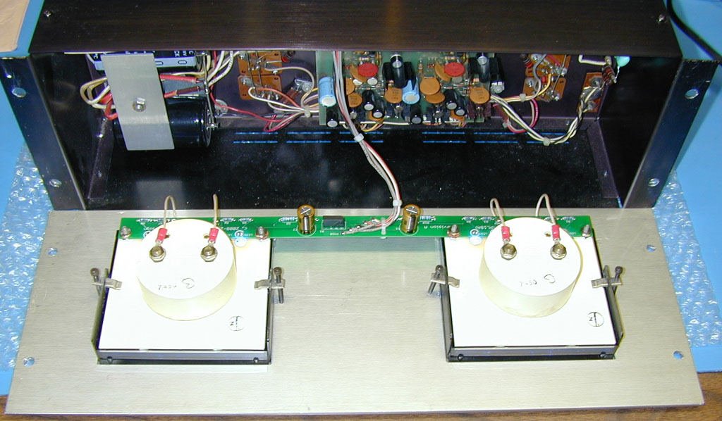

Figure 5 Silkscreen side assembly
- Refer to Figure 6 for the next steps. Flip the board over to the non silkscreened side as shown in the figure. The next 8 components will be installed from the backside of the board.
- Bend the 8 LEDs to the proper shape as shown in Figure 6. Bend the leads right at the body of the LED as this is required to fit into the holes in the meter plastic base, the LEDs just fit. The leads on the LEDs will be at 100 degrees to the cylindrical body of the LED after you have properly formed the leads.
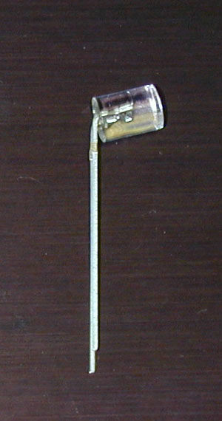
Figure 6 LED Lead Forming at 100 degrees (note short Cathode lead and lead bend close to LED body) ( note alternate LED part numbers may appear visually different than pictured above)
- IMPORTANT! LEDs are polarized. Each LED MAY have a small flat adjacent one of the 2 leads. If it does, this signifies the cathode or negative side of the LED. In case the LED housing does not have this flat section, the cathode lead length is denoted by the shorter of the 2 leads coming out of the LED (see detail in Figure 6). Bend all 8 LEDs in the same direction as shown in Figure 6. The board silkscreen is printed so that it shows this flat. Make sure you install the LEDs with the correct polarity or the light board will not work and you may damage the LEDs or your amplifier, the short cathode lead or flat on the LED body must be oriented to align with the flat silkscreened onto the PCB artwork. Also ensure that you install the LEDs so they point (shine) in the proper direction. The board is asymmetrical with respect to the mounting holes for the board. Look carefully at Figure 7, 8 and 9 for proper orientation. All 8 LEDs should point away from (off) the edge of the board.
- Carefully solder each LED to the board as shown in the Figure 7 and 8. Space the plastic body of each LED 3/16” off the face of the board using the wooden shim supplied in the kit. This will position the LEDs properly to the proper depth to fit inside the meters. Check the polarity of each LED before you solder it into place, aligning the flat (or short lead) on the LED plastic body with the flat silkscreen imprint on the PC board silkscreen. After soldering, clip the excess lead length leaving about 1/16” protruding from the PC board surface.
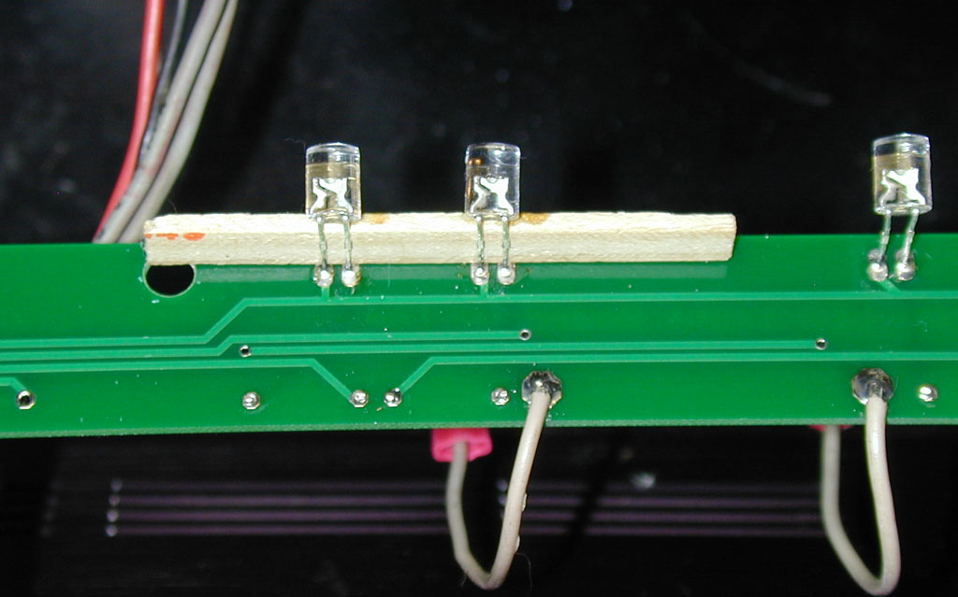
Figure 7 LED spacing at 3/16” using wooden shim ( note alternate LED part numbers may appear visually different than pictured above)
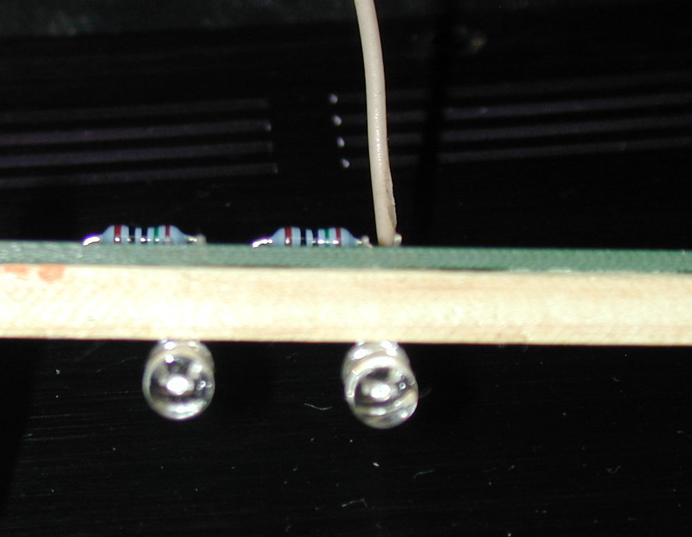
Figure 8 LED spacing at 3/16” using wooden shim ( note alternate LED part numbers may appear visually different than pictured above)
- This completes the Light Board assembly operations that can be performed independently from the amplifier. The next light board assembly steps involve attaching the meter wires and the wire connections from the amplifier to the Light Board. These steps involve partial disassembly of your PL400 amplifier.
- Inspect the finished board for solder shorts or splashes and for proper component orientation and polarity. Touch up as necessary.
- The board is now ready for assembly into your amplifier. The next steps assist you in moving the wires from the original light board onto your new light board.

Installing the light board assembly into the amplifier.

Have a printed copy of these instructions with you prior to performing this installation procedure.
Skill required:
While installation is not a difficult procedure, the installer should be familiar and comfortable with working on electronic equipment and using a soldering station and associated tools. Ensure good control of soldering iron temperature, not exceeding 600 degrees F, so the LED Light Board is not ruined by excessive heat. If you are not familiar with working on electronic equipment or do not possess the proper equipment, it is recommended that you take your amplifier to a service technician that can perform the LED Light Board for you.
Tools required:
- Temperature controlled soldering station or iron – set to 600 degrees F
- 63/37 (preferred) or 60/40 rosin core solder - .031 diameter or smaller
- Needle nose pliers
- Diagonal wire cutters
- Wire stripper – 22 gauge
- #2 Philips screwdriver
- 5/16” nut driver (to remove 4 nuts securing original light board to meters)
- 3/8” nut driver (to remove 4 nuts securing wires on meter terminals)
- 7/16” nut driver (to remove 4 nuts securing aluminum amplifier faceplate)
Step by step installation procedure:
- Disconnect power and all connections from the PL400 amplifier. WARNING! Wait at least 5 minutes for the electrolytic capacitors to properly discharge after unplugging the amplifier!
- Move the amplifier to a suitable, clean work area. It is recommended that a clean sheet of bubble wrap be placed under the amplifier in the work area to prevent damage to cosmetic surfaces of the amplifier.
- Using the 7/16” nut driver, carefully remove the 4 nuts from the backside of the front faceplate screws. Remove the washers that were underneath the hex nuts and carefully extract the decorative faceplate attachment bolts from the faceplate. Put all loose hardware in a safe place for reassembly later.
- After removing the front faceplate bolts, carefully pivot the front faceplate down onto the work surface (protected by bubble wrap to prevent cosmetic damage)
- Locate the original incandescent light board located on the bottom side of the meters that are mounted on the inside of the front faceplate. It is secured to the meters by four 6-32 hex nuts threaded onto screw studs that are part of the meters as well as 4 wires that attach the light board to the connection terminals on the back of the two VU meters (4 white wires) and 5 wires that attach it to the amplifier electronics (2 gray wires, one black, red and white wire).
- Using the 5/16” nut driver, carefully unscrew the 4 hex nuts that secure the original light board to the back of the meters. Put all loose hardware in a safe place for reassembly later.
- Using the 3/8” nut driver, carefully unscrew the 4 hex nuts that secure the original light board meter wires to the terminals on the back of the meters. Put all loose hardware in a safe place for reassembly later.
- The original light board should now be free to allow you to remove it from its original mounting position.
- Using diagonal wire cutters, clip each of the 4 meter wires and each of the 5 amplifier attachment wires right where they were soldered to the original light board. Make these cuts as close to the original board surface as your cutters will allow to preserve the length of the original wires which will be reused in the next steps. Put the original light board aside and out of the work area.
- Using the 22 AWG wire strippers, strip 1/8 to 3/16” from the end of each of the 4 white meter wires and the 5 wires that emanated from the amplifier electronics.
- Using your soldering station, carefully solder the 4 white meter wires to the upgrade LED Light Board at the locations labeled PAD4, PAD5, PAD6 and PAD7 as shown below in Figure 9. The instruction illustrations show these entering from the solder side (non-silkscreen side) of the board and being soldered on the component side (silkscreen side) of the board in order to mimic the assembly of the original light board. It really does not matter which side these wires are soldered on so you can reverse the entry and solder point if you desire.
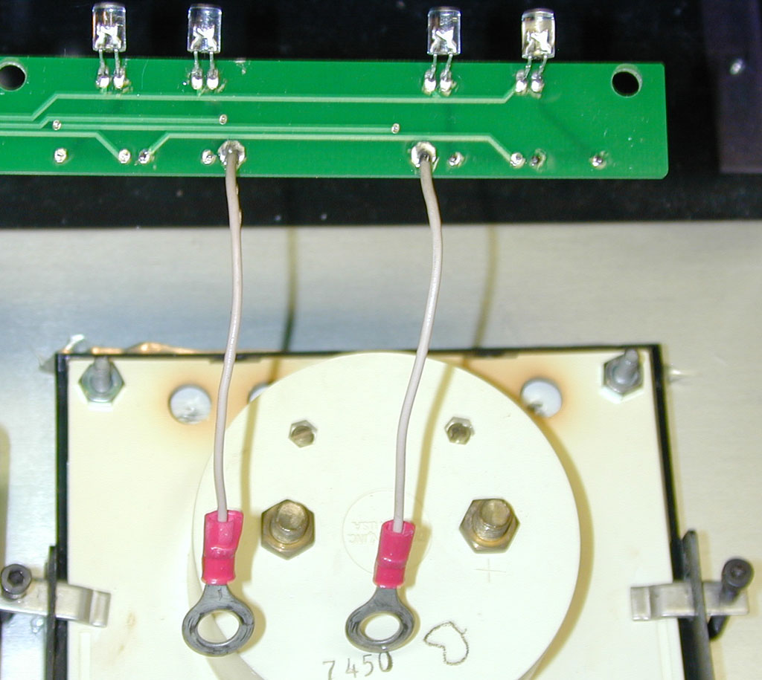
File off LED corners if necessary
File off LED corners if necessary
Figure 9 LED orientation and Meter Lead wires ( note alternate LED part numbers may appear visually different than pictured above)

- Using your soldering station, carefully solder the 5 amplifier wires to the upgrade LED Light Board at the locations labeled PAD1, PAD2, PAD3, PAD8 and PAD9 as shown below in Figure 10. The instruction illustrations show these entering from the component side (silkscreen side) of the board and being soldered on the solder side (non-silkscreen side) of the board in order to mimic the assembly of the original light board. The two gray wires get soldered first to PAD8 and PAD9. These are AC wires so polarity does not matter, both wires are equivalent and either can be soldered to PAD8 or PAD9. Next solder the white, black and red wires respectively to PAD1, PAD2 and PAD3. Do not mix up the wiring order or the amplifier will not work properly or damage will occur to the amplifier.
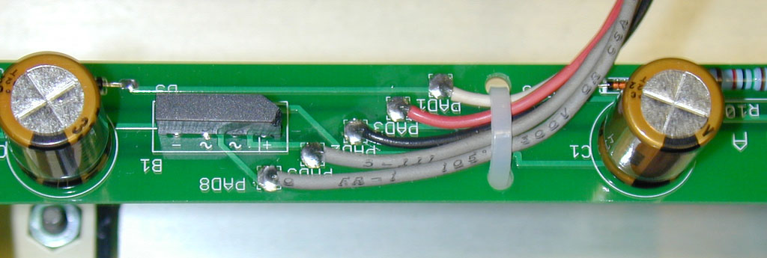
Figure 10 Amplifier lead wire attachment
- Using the ty-rap supplied in the kit, strain relieve the wires to the board as shown in Figure 10 to protect the solder joints. Carefully clip any excess wire length, ensuring that you do not drop any of the clippings into the amplifier circuitry.
- Inspect the finished board for solder shorts or splashes and for proper component orientation and polarity. Touch up as necessary.
- The board is now totally complete and ready for final assembly into your amplifier. The next steps assist you in mounting the LED Light Board into the amplifier.
- Install the four 6-32 spacer hex nuts provided with your kit on the meter studs and tighten finger tight. Two of these are shown in Figure 9. Often the meter plastic housing is brittle and discolored from the heat produced by the original incandescent light bulbs on the original light board. As a result, the plastic may be somewhat fragile. Be careful when tightening these nuts to ensure you do not damage the meter.
- Next install the new LED Light Board on top of the meter studs. Carefully guide the blue LEDs into the 4 holes in the back of each meter. Carefully make minor adjustments to the LED positioning while doing this by carefully bending the LED leads slightly. The LEDs just fit into the meter holes so be very careful when performing this assembly operation. If you cannot make the LEDs fit, file a small amount off the corner of the LED using a jeweler’s file in the area indicated in Figure 9.
- After getting the new LED Light Board to seat properly on meter studs, install the original hex nuts to secure the Light Board in place. Tighten gently using the 5/16” nut driver. DO NOT OVERTIGHTEN or you can damage the meters or the LED Light Board.
- Attach each white meter wire to the respective meter terminal using the 3/8” hex nuts removed in the earlier step. Each wire attached directly to the terminal that is directly above the attachment point on the LED Light Board, orientation is obvious. Please refer to Figure 5 and Figure 11 for a picture of this. Tighten gently using the 3/8” nut driver. DO NOT OVERTIGHTEN or you can damage the meters.
- Once installation is complete, your light board will look like the illustration in Figure 11 below. Make any minor adjustments to the LED orientation necessary to ensure that they point uniformly into the meters.
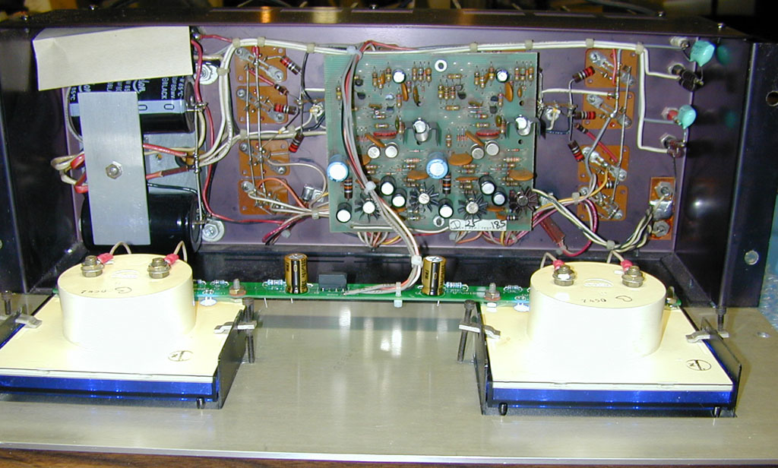
Figure 11 Installed LED Light Board Assembly
- Dress the amplifier wires neatly using ty-raps provided to neaten up your installation as shown in Figure 11.
- Pivot the front faceplate back up into place while ensuring that there is not interference with any amplifier components or any wire pinching.
- Secure the front faceplate using the original hardware in the reverse order of step 3 and 4. Do not over-tighten the faceplate screws or you may damage the amplifier cosmetics. When completed, your project will look like Figure 12 below.
Figure 12 Finished PL400 LED Light Board Project
- Enjoy your amplifier’s new long-life light board. Tell your fellow vintage audio enthusiasts about White Oak Audio Design and our fine products.

Revision Table
Revision | Revision Notes | Revision Date | Revised By
A | Original Release | 5/17/2009 | JPK
B | Revised to show alternate LED and rectifier bridge part numbers in Bill of Materials | 8/24/2009 | JPK

